**Information Security**

**COMP-421**

**Section-B**

**Assignment - 1**

**Hannan Zahid**

**241545586**

Link 1 Commands:  
<https://www.offsec.com/metasploit-unleashed/port-scanning/>

**Nmap & db_nmap:**

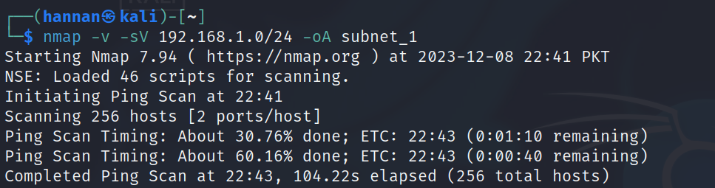

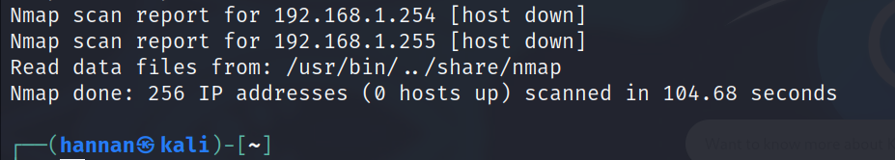

**Port Scanning:**

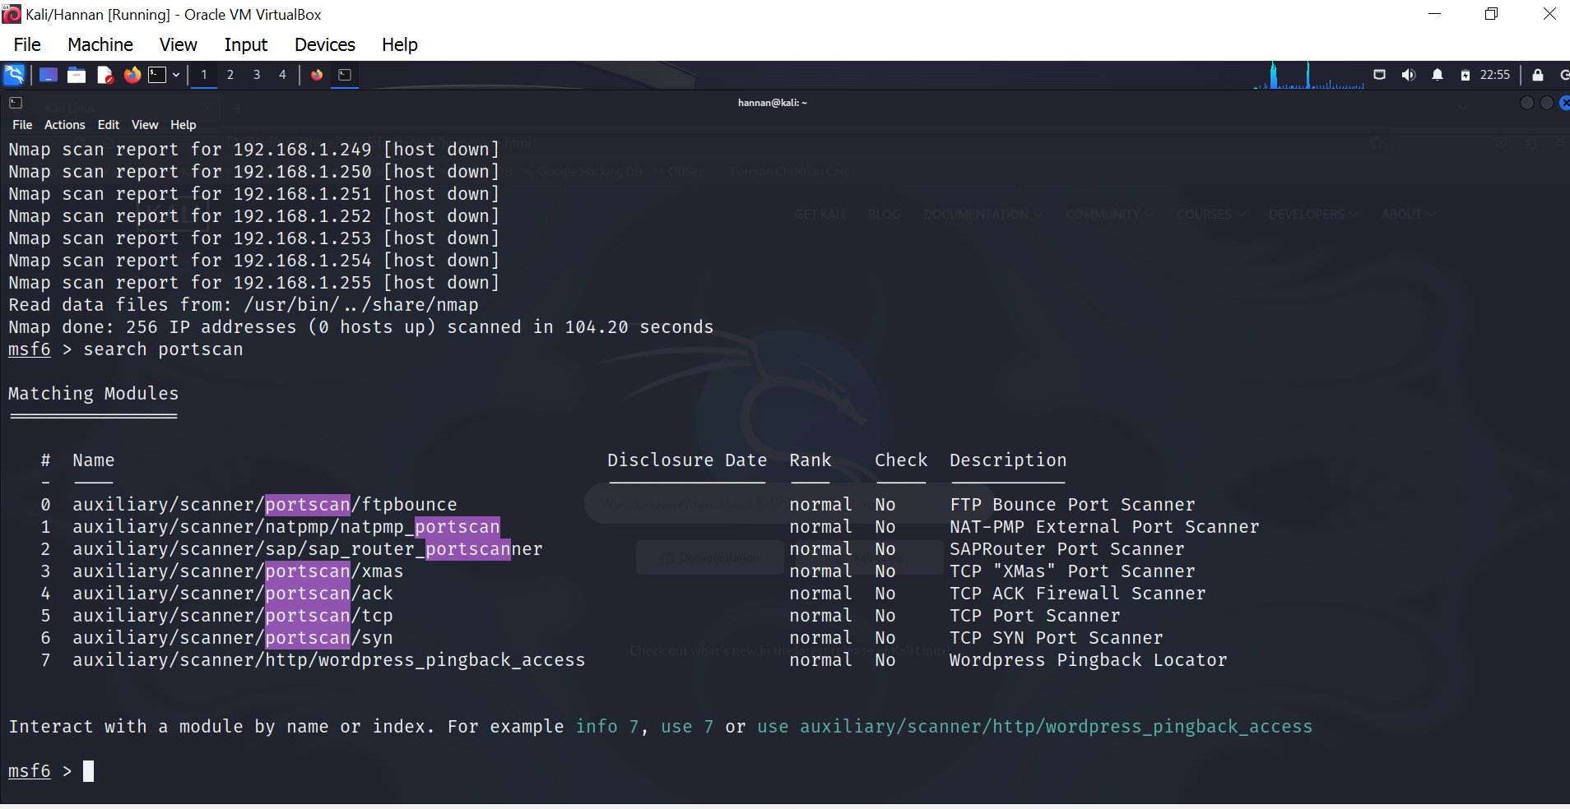

**Cat Subnet:**

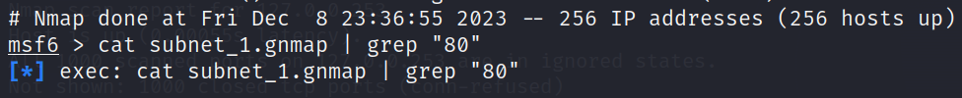

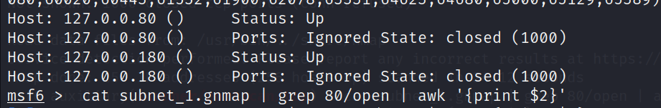

**SYN Scan:**

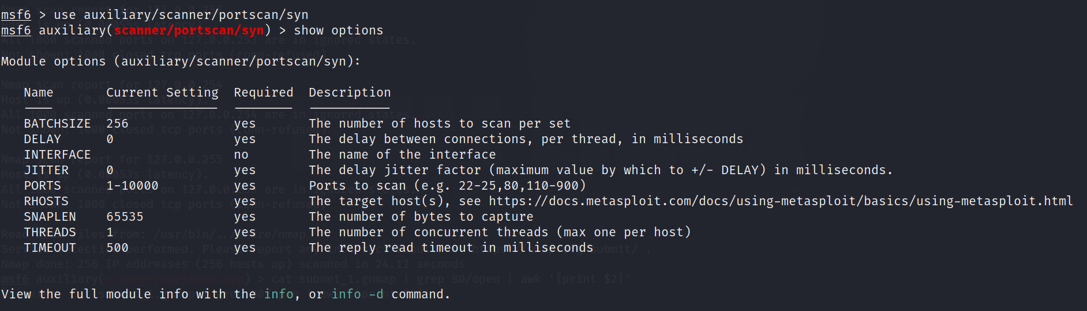

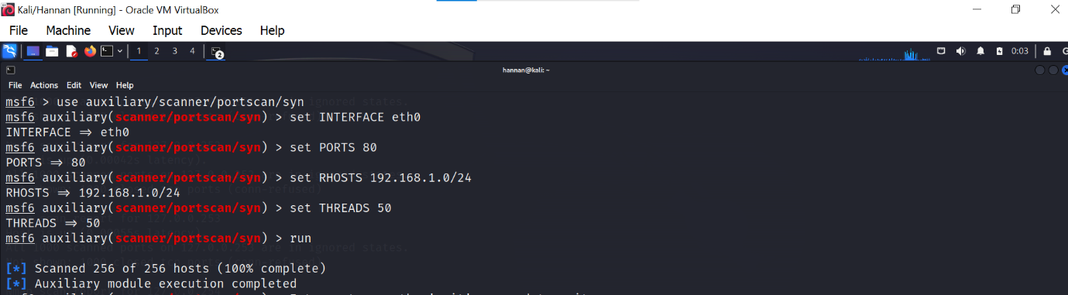

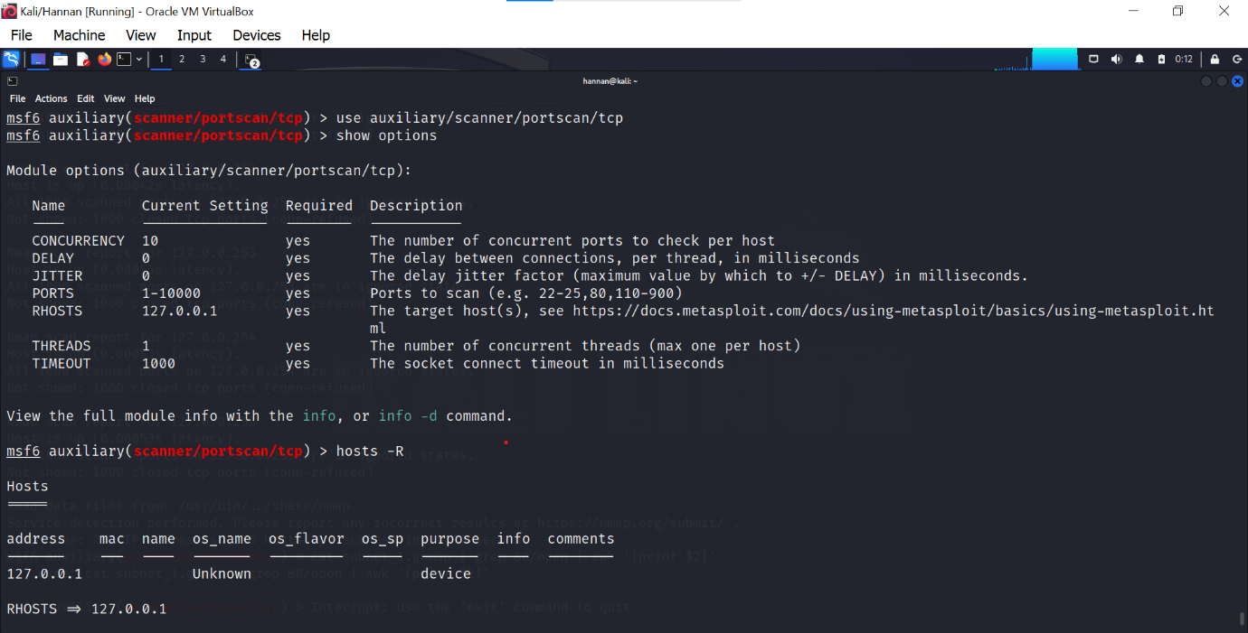

**Run Command:**  
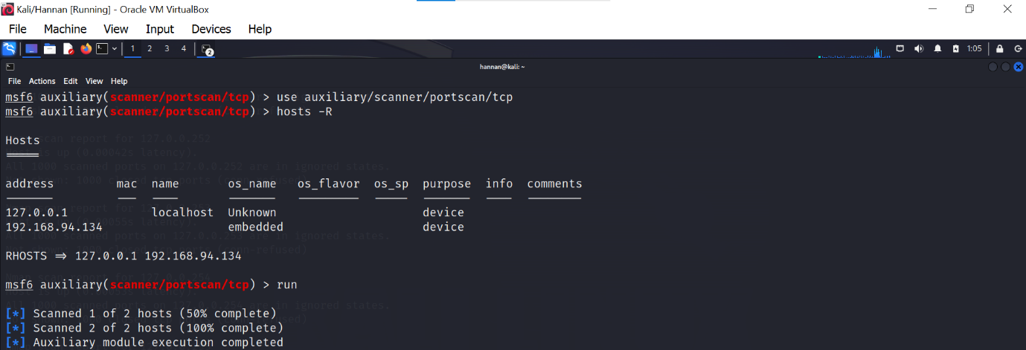

**SMB Version Scanning:**

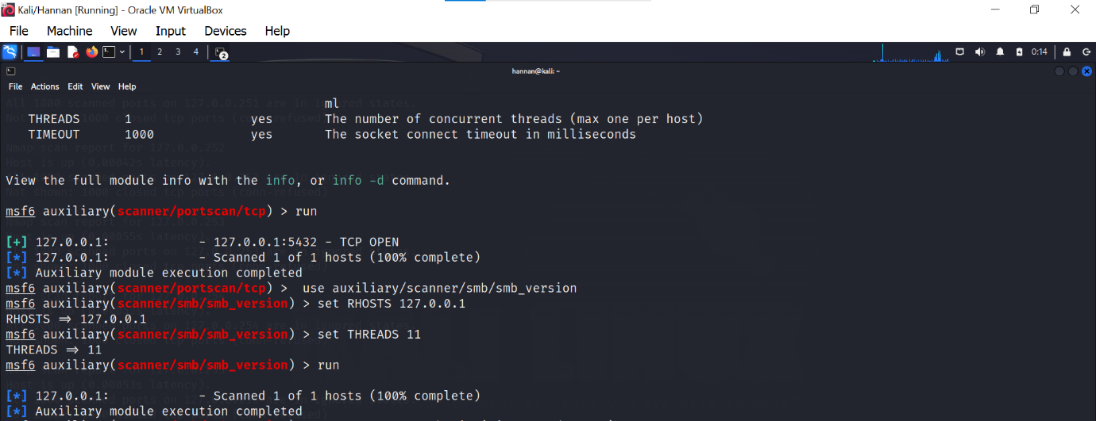

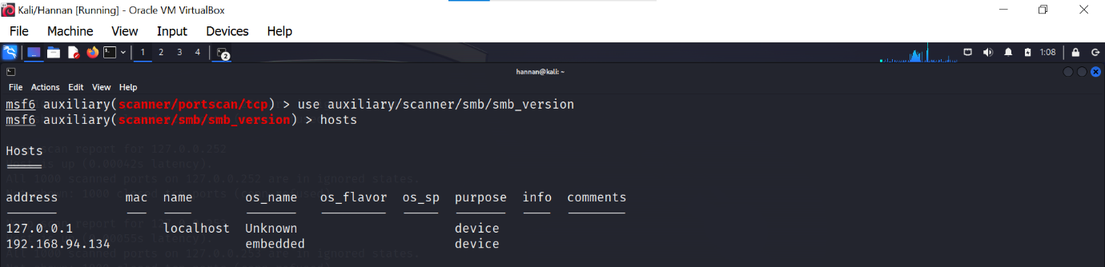

**IDLE Scanning:**

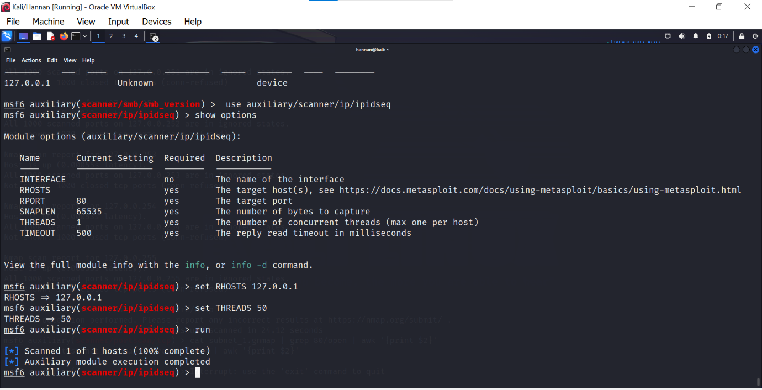

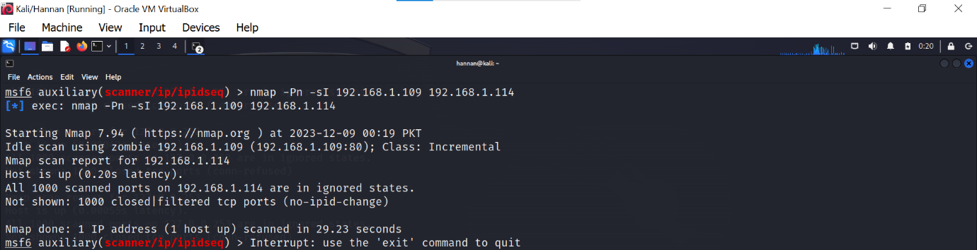

**Link 2:**

<https://www.cm-alliance.com/cybersecurity-blog/using-metasploit-and-nmap-to-scan-for-vulnerabilities>

**Using Metasploit and Nmap to scan for vulnerabilities:**

use auxiliary/scanner/portscan/tcp

set PORTS 22,25,80,110,21

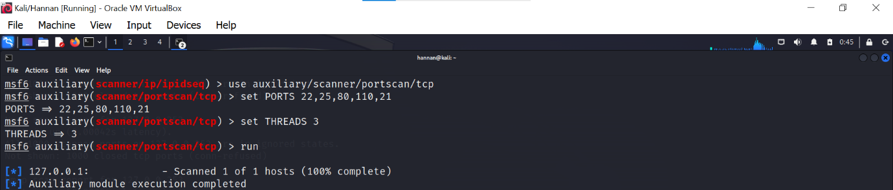

**Combining Nmap with Metasploit for a more detailed and in-depth scan on the client machine:**

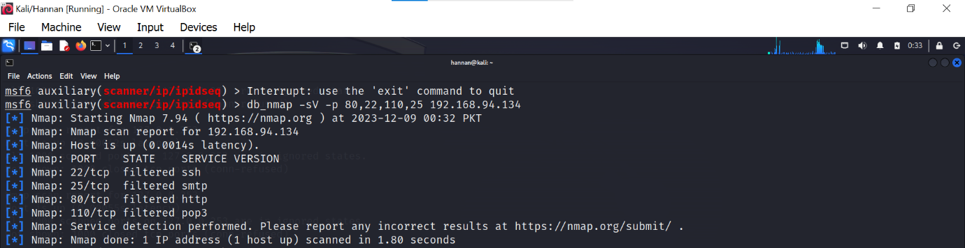

## ****Scanning for vulnerabilities with Nmap and Metasploit:****

## C:\Users\Hi\Desktop\scanning vuln with ms and nmap.png